CS-330 Comp Graphic and Visualization

Final Project Reflection

Peter Taylor

The Scene
My scene consists of three dice and a timer. All together this scene has four objects, one simple and three compound. It is made up of a combined total of one plane, two boxes, two tapered cylinders, four pyramids, and seven cylinders.
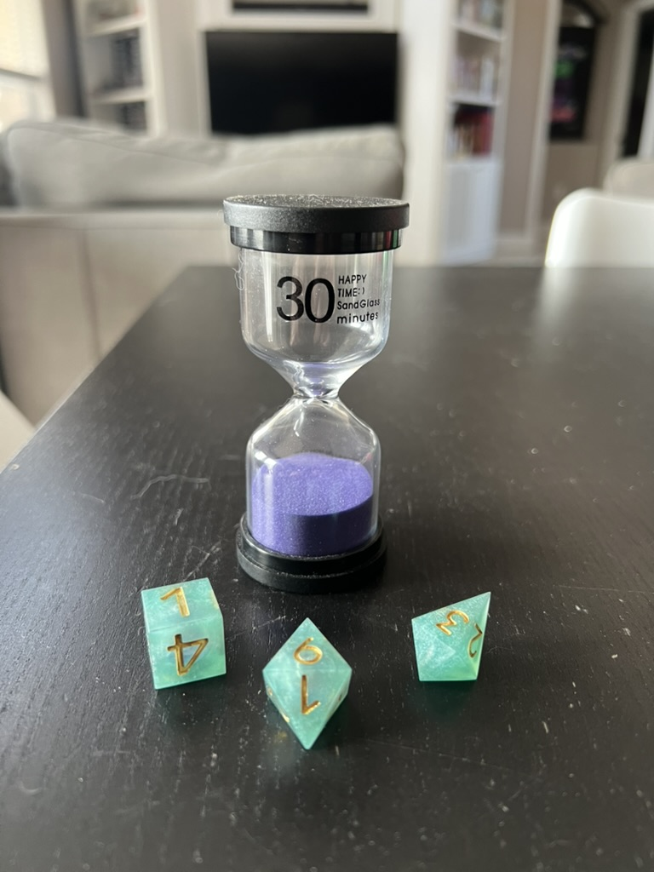
The dice and timer sit on a wooden table surface made up of a single box object. There is plane object used as a backdrop.
The dice represent basic shapes, but only one object, the 6-sided die, can be represented by a single basic 3D shape. This will be replicated with a simple box object.
The other 2 dice are each a combination of pyramids. While the 8-sided die consists of two identical pyramids combined at their square bases, the 4-sided die consists of 2 pyramids of the same base dimension and different heights. The shorter pyramid is a little squashed compared to the relative dimensions of the pyramids in the 8-sided die while the taller pyramid is stretched considerably.
The final object, the 30-minute timer, has three main components: the top and bottom caps, and the hourglass. The object overall consists of seven cylinders and two tapered cylinders. Starting at the bottom there is a thin wide cylinder with a slightly narrower cylinder stacked on top of it. Next is added a cylinder for the sand in the timer. The glass of the hourglass begins with a hollow cylinder sitting on top of the two base cylinders. It is slightly wider and a bit taller than the sand cylinder. Next is stacked a hollow tapered cylinder with another hollow tapered cylinder on top of it. A final hollow cylinder completes the hourglass. Lastly, the top cap is made up of a wide short cylinder and another slightly wider short cylinder.
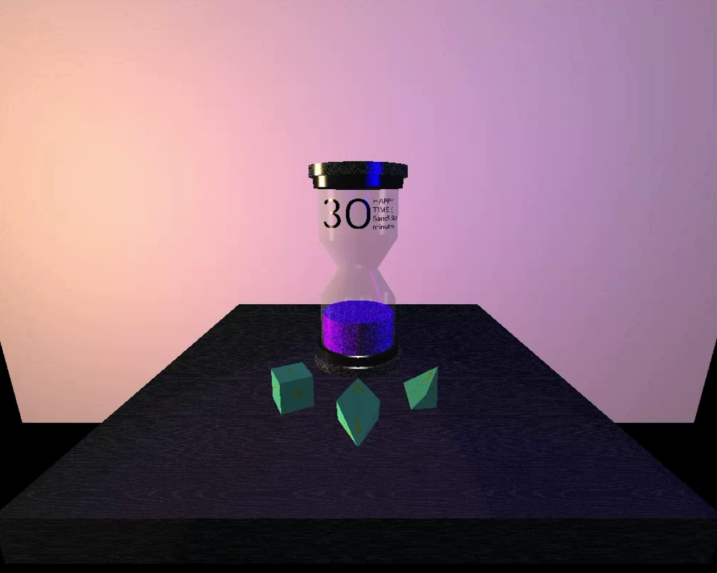
Programming the glass and sand in the timer was a bit challenging. It took some research to figure out the exact order in which to place the objects to achieve the proper look of the glass. I had to change some settings for the glass to render transparently but found that if I tried rendering the sand after wards the sand would also be transparent. Adding the sand cylinder first and enabling color blending achieved the correct look.
The four and eight-sided dice posed their own challenges to get looking correct. Size and positioning took a lot of trial-and-error, especially for the four-sided die since it was intentionally positioned at an arbitrary angle.
Though I tried to keep my model colors and textures close to the real scene, I took some creative liberty with the lighting. I found that using multiple lights of different colors and positions really helped showcase the dimensionality of the timer. This is more evident as you navigate around the scene.

Navigation
Moving around the scene is handled by mouse and keyboard input. The mouse changes the direction that the camera points relative to the position of the cursor in the window. While the mouse cursor is to the right of center, moving the mouse rotates the camera to the right. When the cursor crosses to the left of center the camera rotates to the left. Same with up and down.
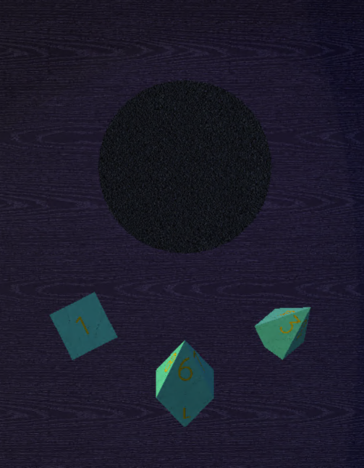
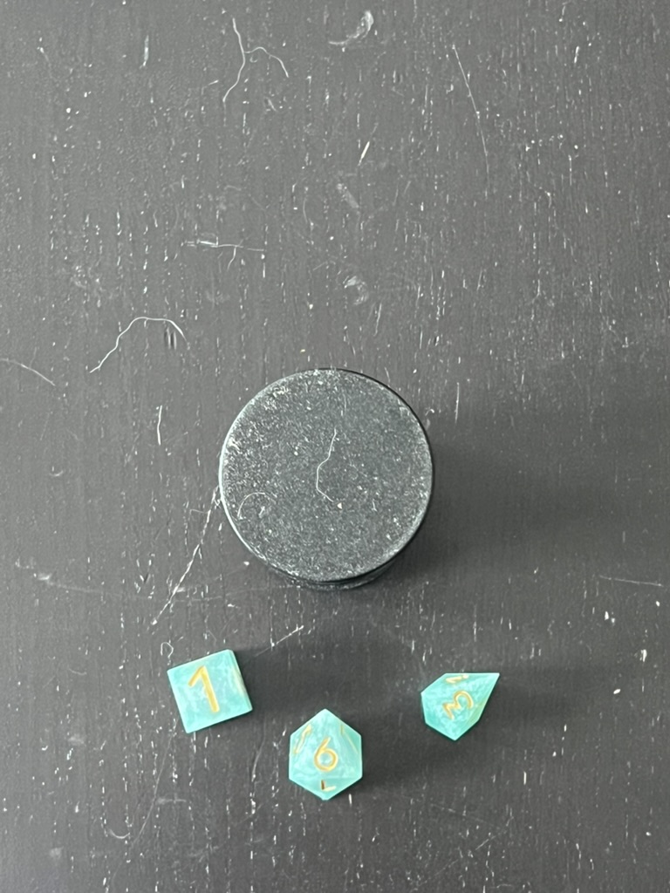
The keyboard moves the camera around the scene. The W and S keys move the camera forward and back while the A, and D keys move the camera left, and right respectively. The Q key pans the camera up while the E key pans the camera down. The scroll-wheel on the mouse changes the speed of the camera movement, scrolling up slows the movement down and scrolling down speeds it up.
There are also keys that change the projection view. The O key is used to show a frontal orthogonal view, and the P key is used to return to a default perspective view. You can also use T for a top-down orthogonal view, L for an orthogonal view from the left, R from the right, and B for an orthogonal view from the back.

Custom Functions
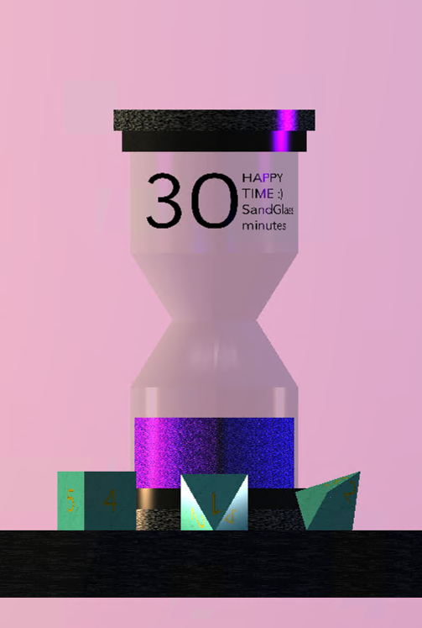
During development I attempted to keep my code clean by creating smaller worker functions for implementing more complicated tasks. Keeping implementation details inside small functions makes the overall code easier to read and maintain. Combined with well named functions, this helps the developer reading the code follow what is being done at each step without being burdened with having to understand how it is being done.
One example of this approach is that each shape in the scene has its own render function. The RenderScene function then calls each of these functions in turn. The RenderBackdrop, RenderFourSidedDie, and RenderTimer functions very clearly explain what their function is.
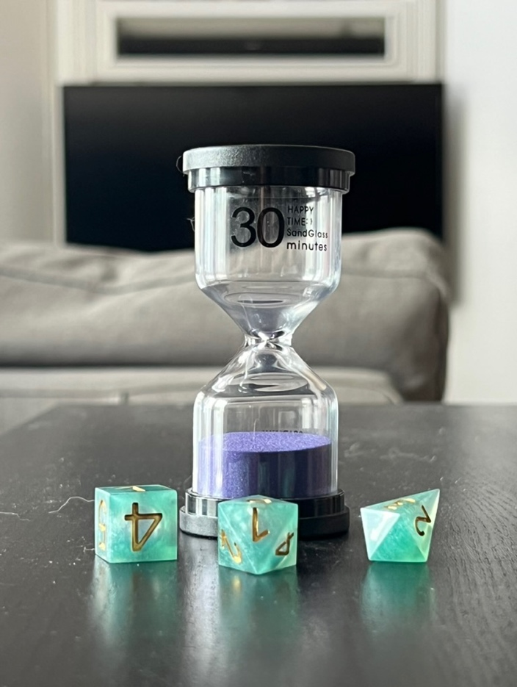
RenderTimer is much more complicated than the other individual objects, and so it calls several other helper functions to construct the timer in stages. There are three separate helper functions used to build the timer, RenderTexturedCylinder, RenderSmoothCylinder, and RenderHourglass, the first two functions being called twice. Another benefit of this approach is that it allowed me to more easily adjust the parameter of the hourglass to dial in the size. Each of these functions required parameters to be passed in that were used for the diameter, height, and positioning of the cylinders. Passing in variables that were declared at the top of the RenderTimer function made it easier to adjust values in a single place in code while testing the look of the timer.

